# PHASE II: HOTEL BOOKING SYSTEM BUSINESS PROCESS MODELING.

**Project Title:** Hotel Booking System  
**Course:** PL/SQL Capstone Project (INSY 8311)

**Lecturer:** Eric Maniraguha

**Phase 2 Focus:** Understanding and modeling how the system works before building the database

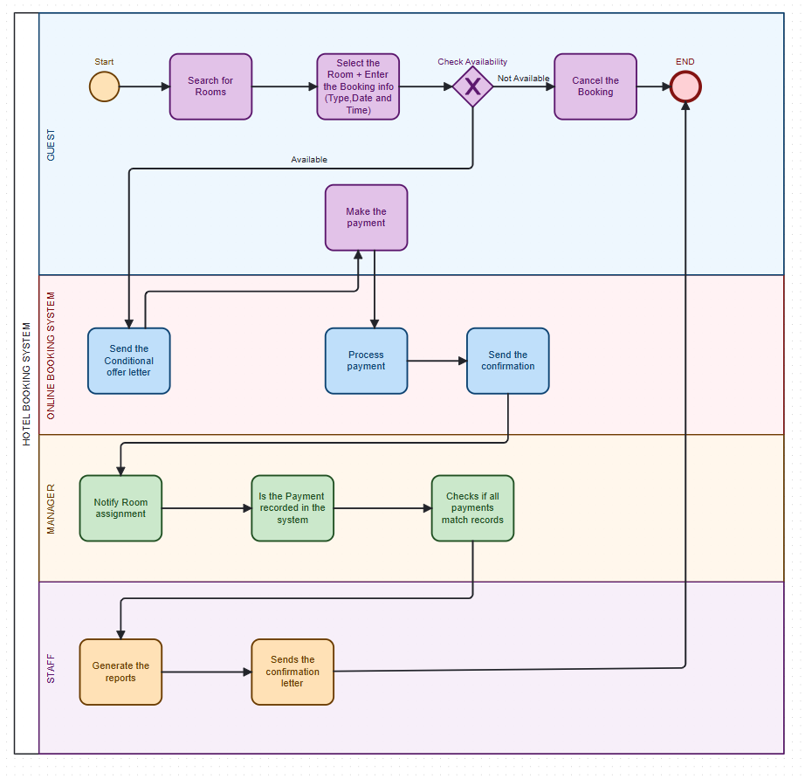

## Introduction

In this phase, we were asked to model a real-world **business process** that shows how information moves between people and systems. This is part of **Management Information Systems (MIS)**.

The main goal is to **visualize how our hotel booking system works** — step by step — and to understand how different users interact with it. We used a **process diagram with swim-lanes** to clearly show which part is done by the **Guest, System, Manager, or Staff**.

**This helps us:**

* Know what the system should do.
* Plan how the database will support each activity.
* Make sure everyone’s role is clear.

## Explaining the Diagram Step by Step

The diagram is divided into **four swim-lanes**. Each swim-lane shows the actions done by a specific user or system.

### *1. Guest (Top Lane)*

This is the person who wants to book a room.

1. **Start:** The guest begins the process.
2. **Search for Rooms:** The guest looks for available rooms on the hotel’s website.
3. **Select Room + Enter Booking Info:** They choose a room and enter the booking details (type, date, time).
4. **Check Availability:** The system checks if the selected room is available.
5. ❌ If **not available**, the guest gets an option to **Cancel the Booking** → and the process ends.
6. **✅** If **available**, the guest is allowed to **Make the Payment**.

### *2. Online Booking System*

This is the system that works in the background to process information and automate tasks.

1. **Send Conditional Offer Letter:** After availability is confirmed, the system sends a conditional offer to the guest.
2. **Process Payment:** The system processes the payment made by the guest.
3. **Send Confirmation:** If the payment is successful, a confirmation is sent to the guest and the manager.

This part of the system automates most of the work and helps the hotel respond quickly.

### *3. Manager*

The manager handles the back-end tasks to make sure everything is correct.

1. **Notify Room Assignment:** The manager assigns the booked room to the guest.
2. **Check if Payment is Recorded:** The manager checks if the payment is shown in the system.
3. **Verify Records:** The manager also checks that the payment matches what is recorded in their official records.

This ensures there are no mistakes or missing payments.

***4. Staff***

The staff finalize the work and help with reporting.

**Generate Reports:** Staff create reports based on bookings and payments. These reports help with planning and analysis.

**Send Final Confirmation Letter:** Staff send a final confirmation to the guest after everything is confirmed.

## Why This Process is Useful for MIS

This process supports **Management Information Systems (MIS)** in several ways:

1. **Improves decision-making:** Managers can trust the system to give real-time updates.
2. **Automates tasks:** No need to do things manually like confirming payments or sending emails.
3. **Tracks data:** Reports are generated automatically, which helps the hotel analyze performance.
4. **Clear roles:** Everyone (guest, manager, staff) knows what they should do.

## Conclusion

To sum it up, **this diagram clearly shows how the hotel booking process works** — from when a guest starts searching for a room to the final confirmation by staff. By using **swimlanes**, we made it easy to understand who does what.

This phase is very important because:

* It helps us design the system properly.
* It shows us how to organize our tables and logic in the next phase.
* It improves how the hotel works by making everything smooth and automatic.

Understanding this process will guide us as we start creating our database using PL/SQL in the coming phases.